GitHub report:

The first thing to do is install git. The default my shell is .zsh and not bash. For this we need a \bin\bash shell. In order to change the shell, the commands used were:

lucia@lucia-R519-R719[lucia] chsh
Password:
Changing the login shell for lucia
Enter the new value, or press ENTER for the default
Login Shell [/bin/zsh]: /bin/bash
lucia@lucia-R519-R719[lucia] bash
lucia@lucia-R519-R719:~$

When the shell is changed, now is time to install git.
lucia@lucia-R519-R719:~$ sudo apt-get install git
Steps:

1. Create a profile:
Login the GitHub website https://github.com and create an account.
When the account is created, personalize it like in the figure 1.
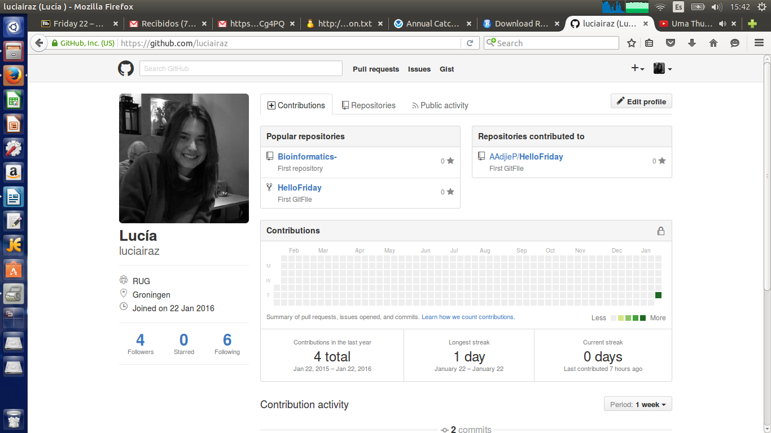
2. Create a repository:
Click on the + symbol right next to the profile option, it will display a menu with two options:
New repository
New Issue
Click on the New repository option. The window that will appear is:
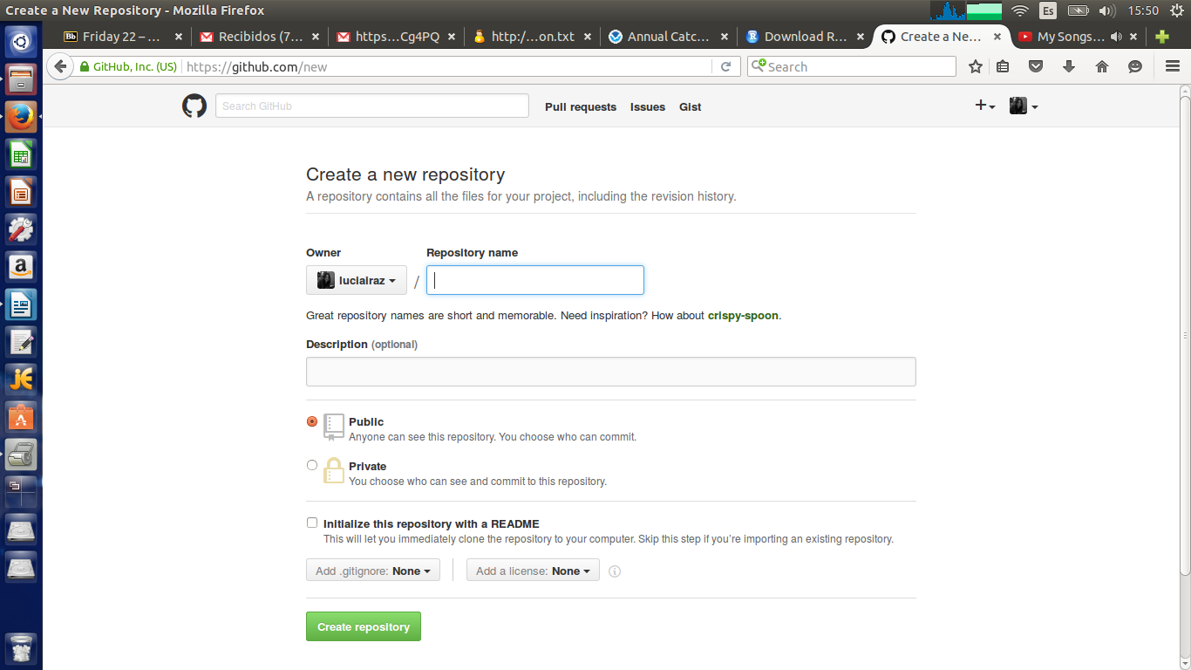

You only have to put the name of the repository, add a brief description, keep the public tab. Click on the “Initialize this repository with a README” option. Add .gitignore, Python.
Create the repository.
3. In the terminal, we are going to put the files in our computer:

lucia@lucia-R519-R719:~$ git clone https://github.com/luciairaz/Bioinformatics-.git
Cloning into 'Bioinformatics-'...
remote: Counting objects: 4, done.
remote: Compressing objects: 100% (3/3), done.
remote: Total 4 (delta 0), reused 0 (delta 0), pack-reused 0
Unpacking objects: 100% (4/4), done.
Checking connectivity... done.
lucia@lucia-R519-R719:~/Bioinformatics-$ git status
On branch master
Your branch is up-to-date with 'origin/master'.

Untracked files:
(use "git add <file>..." to include in what will be committed)

Untitled Document
luciairaz
luciairaz.txt
lucia@lucia-R519-R719:~/Bioinformatics-$ git add --all :/
lucia@lucia-R519-R719:~/Bioinformatics-$ git status
On branch master
Your branch is up-to-date with 'origin/master'.

Changes to be committed:
(use "git reset HEAD <file>..." to unstage)

new file: Untitled Document
new file: luciairaz
new file: luciairaz.txtlucia@lucia-R519-R719:~/Bioinformatics-$ git add --all :/
lucia@lucia-R519-R719:~/Bioinformatics-$ git status
On branch master
Your branch is up-to-date with 'origin/master'.

Changes to be committed:
(use "git reset HEAD <file>..." to unstage)

new file: Untitled Document
new file: luciairaz
new file: luciairaz.txt
lucia@lucia-R519-R719: git commit -m “project”
lucia@lucia-R519-R719: git push
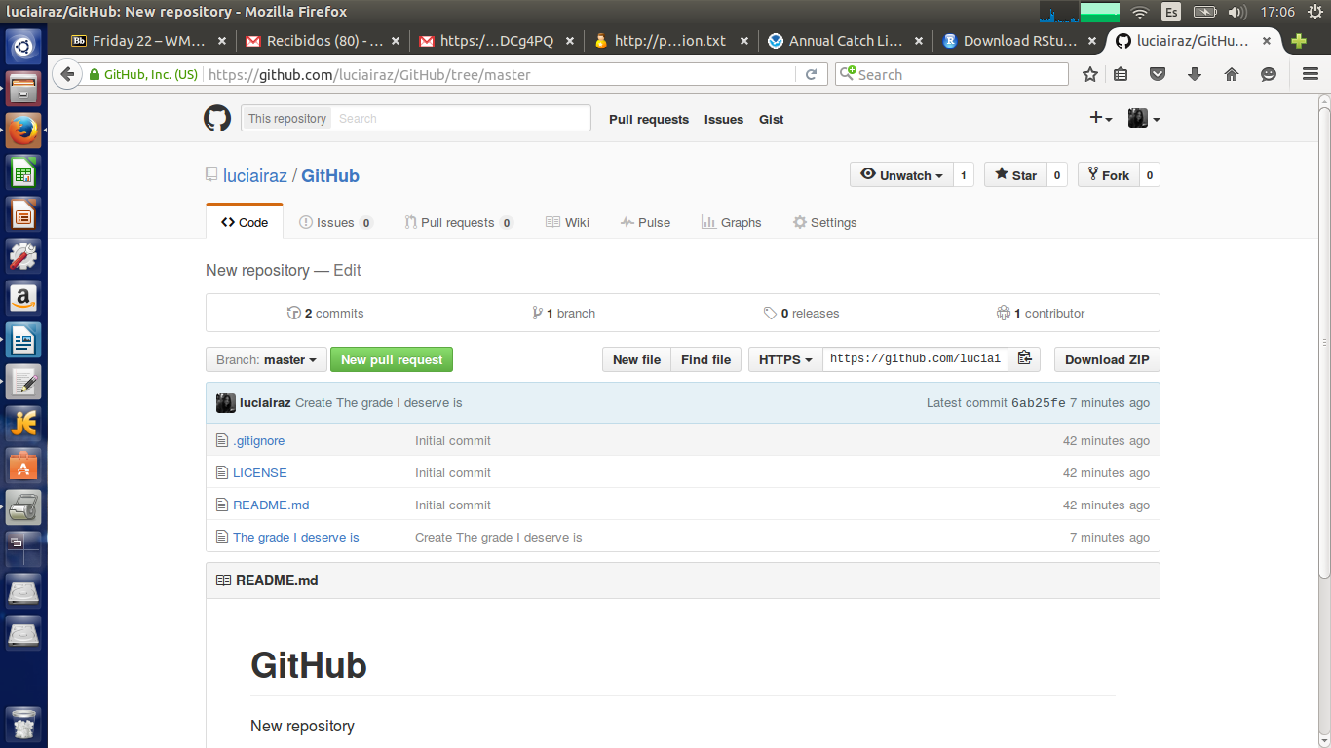
Another thing that we could do was to make collaborations with some colleagues. With the commands:
git pull
echo '2' >> plans.txt
git add –all :/
git commit -m 'Added 2'
git push
#With those commands I am entering some information in the repository that my colleague wants me to collaborate in.

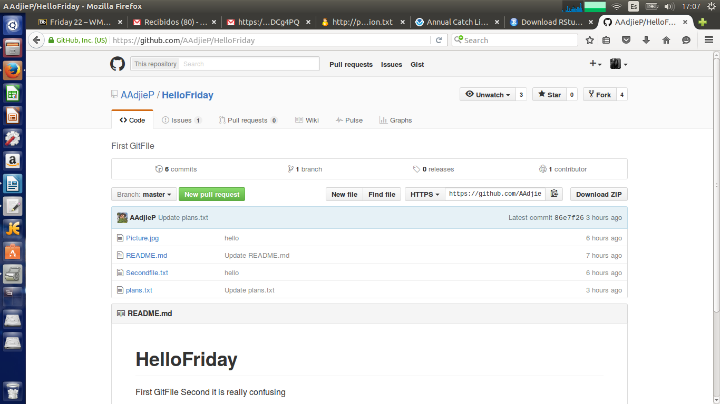

In order to make the collaboration work, you can do it with issues, in which you can send messages to the people you are collaborating with.
